Student activity [output O1-C-3, en, license CC BY 4.0, 5 July 2018]

Check your personal “referencing style“!
Date: 2018-07-05
Information about the use of this material:
This work is licensed under a Creative Commons Attribution 4.0 International Licence.
You are free to share, copy and redistribute the material in any medium or format. You are free to adapt, remix, transform, and build upon the material for any purpose. You must give appropriate credit, provide a link to the license, and indicate if changes were made. You may do so in any reasonable manner, but not in any way that suggests the licensor endorses you or your use.
Additional information about CC licensing: https://creativecommons.org/licenses/by/4.0

citation:
[editor] Project Refairence
[title] Check your personal referencing style!
[date] 2018-07-05
[source] http://www.academicintegrity.eu/wp/all-materials
[access date]
Acknowledgements
Design by Project Refairence in cooperation with Diana Schmidt-Pfister, Lehrmedienwerkstatt, Center of Excellence 16, University of Konstanz, Germany; and Teddi Fishman, South Carolina, USA
Artwork by Sabina Krämer. English translation by Helen Bassett.
Inspired by material from several other colleagues, e. g. the Schreibtypentest, Schreibzentrum Universität Frankfurt, http://www.starkerstart.uni-frankfurt.de/43833603/_schreibtypentest [24 Oct 2016].
What is your personal style of referencing?

Referencing results, data, phrases or ideas (hereafter summarised and referred to as content) is fundamental for the academic community. You might have already had to deal with this subject before in your studies.
But how do you personally go about referencing?
For each of the 6 questions select the answer that best suits you and your working method.
At the end you will find out what your style of citing sources is like. You can then read on to find out what the strengths and weaknesses of your approach to referencing are. In addition, you will get tips on what you could do better.
When the questions mention “work”, this refers to your writing tasks, regardless of whether they are assignments, projects, reports, experiment protocols, the final paper or others.
Let’s get started!
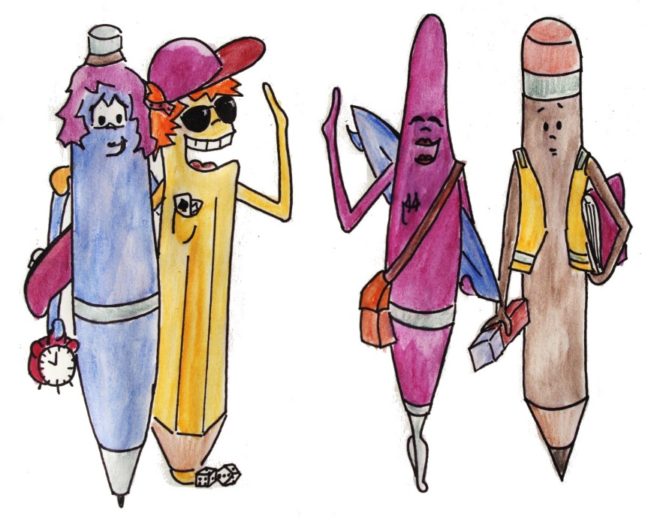

1) When writing up your work, how careful are you about referencing content in detail?

B I always try to reference in detail, but it’s more important for the content to be correct.
A Very, so that the reader can easily check my sources and results.
D I pay a lot of attention to it, because I would otherwise be afraid of my work being marked down.
C Not very. Referencing is so tedious.

2) Before submitting a finished piece of work do you ask someone to read through and provide feedback whether content used from other sources is distinguishable from your own reasoning/contribution?

A Yes. I’m interested in their tips in order to improve my way of working.
D Yes. That way I can eliminate mistakes I made.
B Sometimes. It depends on how much time I have left.
C No. Usually I don’t. Why should I?

3) The submission deadline is tomorrow. Your work is finished, however, when checking through it you realise you’ve missed out a citation for one piece of information that is critical to your main argument. What do you do?

C I hand the work in as it is. I’m not fussed. It’s only one place, after all.
B I simply remove it from my text. It’s not worth the effort finding the source again. The main thing is that the work is finished.
A I organise my notes and sources orderly. Therefore, I can find the source and add the citation in.
D I look for the source until I’ve found it. In addition, I check my whole work over once again for referencing mistakes.

4) If someone were to check over your work very closely. Do you worry that they will find referencing mistakes or even plagiarism?

D Even though I checked everything, I still do worry, but I hope that I have done everything correctly.
B Actually I don’t worry. Of course I could have made some small mistakes, but that wouldn’t be that much of a problem.
C Why? Even if I have made some mistakes – no one will realise.
A No, because I have acknowledged all the content I’ve taken used from other sources.

5) You use an image from a textbook as prove for your reasoning in your work, however the page number is missing in your citation. You gave the book back ages ago and your notes can’t help you further. What do you do?

B I will look for an alternative image or prove. If there is none, then I will just leave the page number out.
A I order the book in the library once again and find the page.
D I don’t have that problem. I don’t give the books back until after the submission deadline.
C I just add in any old page from the book that could fit.

6) You download a podcast with an interesting expert interview on your research topic. You would now like to use some of the content in your work, but it is unclear how and whether you can reference the podcast. What do you do?

D I avoid using the source.
C I incorporate the information in my work. I will think about how to reference it later.
A I look into referencing guidelines or ask my lecturer(s).
B I see what I can find out about it on the Internet.

So, what is your personal referencing style? – Score

Count your answers. Then you’ll see what your style is straight away.

Answer | Score | Your personal referencing style
A |  | Hazardous
B |  | Efficient
C |  | Thorough
D |  | Careful

Read on to find out what the strengths and weaknesses of your approach to referencing are. In addition, you will get tips on what you could do better.

Type A: Hazardous
“I hope I’ve played my cards right…yes, managed the pass mark!”

When it comes to academic writing and referencing you take serious risks. You have admittedly already heard that there are special requirements for academic working methods. You should work according to these requirements however you do not do this consistently. You probably look for easy ways to finish your tasks or you’re not really sure how you are supposed to work. Or maybe other things are more important to you and you hope that you manage to get away with it and will be dealt a good hand with your marks. In any case, you seem to have a rather relaxed view on professional working methods. It might be unclear to you why academic working techniques and referencing are such hotly debated topics or you might consider them to be overvalued and a negligible aspect of your work.
This leads to a good chance of you plagiarising and making mistakes in your texts.
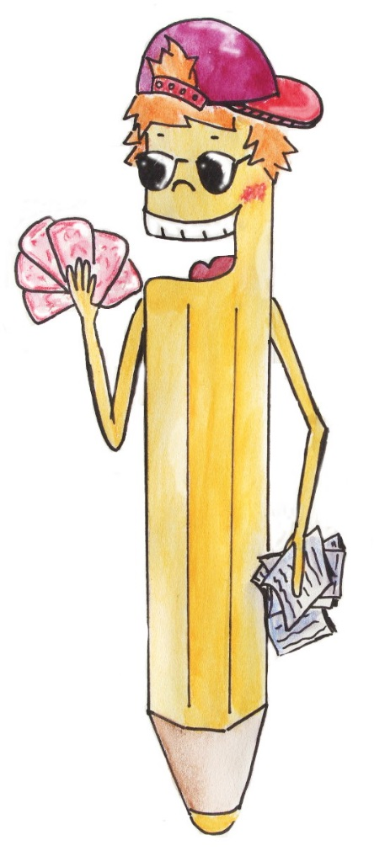
The strengths of your working method are:
None.

The risks of your working method are:
- You should care more how or whether content from other sources and references is organised in your work. You can therefore easily end up making mistakes or plagiarising. Even many small referencing mistakes can lead to your work being marked down.
- You document your sources in a rather chaotic fashion. That’s how you can easily end up making mistakes with indirect quotes, paraphrases, using images, data, and much more. If you’d like to check something it requires a lot of time.
- You have problems managing your time and you can end up running out of it. You can then neither check your work nor ask someone to give you feedback on it. Serious referencing mistakes can therefore go unnoticed.
- Guessing, making up or consciously leaving out referencing information – even if it’s only a page number – is unprofessional. It interferes with comprehension and deceives the reader.

Learn basic academic working methods and apply them!

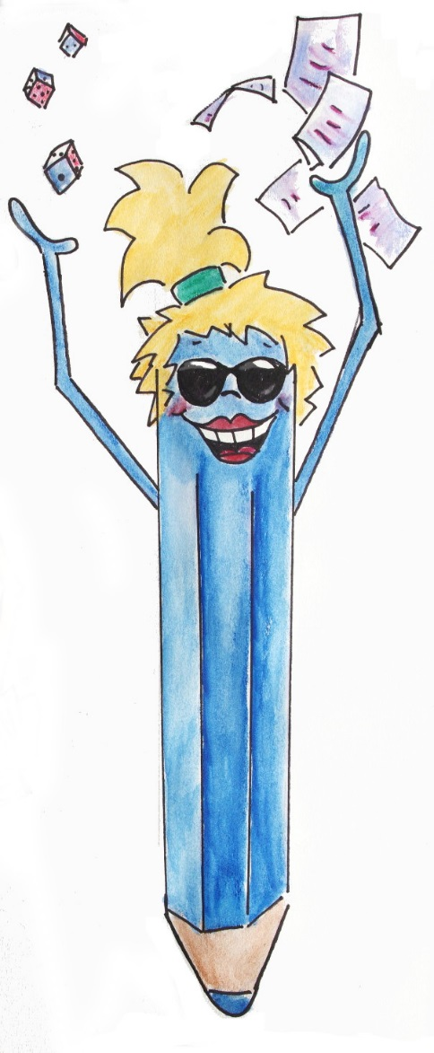
Tips & tricks

- Get engaged in the meaning, purpose and relevance of academic working techniques. It will then be easier for you to understand how the academic community works and why an exact working method is important at university. It can help you be successful in your studies and your future working life. Referencing is not a formal duty to be fulfilled as an end in itself. It is necessary for many reasons; to be able to check findings, acknowledge who bears responsibility for them and show appreciation of other people’s work, among others. Moreover, you will be marked on whether you command professional working techniques. This is because acknowledging sources you have used is the first step for the reader to be able to understand what material you’ve used and how you’ve reached your results.
- Check how you process, evaluate and finally incorporate content from sources in your work. Always keep referencing information on your sources available together with the content. If you improve your working method, you’ll be able to further reduce the likelihood of making mistakes.
- Improve your time management, for example, allow enough time for checking and getting feedback. Then you can calmly check through your references once again.
- Get to grips with writing and referencing. It is exactly when writing doesn’t come easily to you or methodical work seems annoying that you should use the opportunity to practise and improve these skills. With time these skills will then come easier to you. Whether or not you have mastered the appropriate working techniques will be crucial in your final paper at the latest.
- Use reliable sources for finding information, even for working methods and referencing conventions. Examples of reliable sources are handbooks, online offers from the university and lecturers.
- Document your working process and progress. That way you can always track the development of your ideas and show this to people if they want to check how you’ve reached your results.
- Use appropriate offers of guidance and teaching at your university and in your degree course. These could include writing and IT skills, using the library, time management, managing your references, academic writing, etc.

Type B: Efficient
“The main thing is that my work is finished on time.”

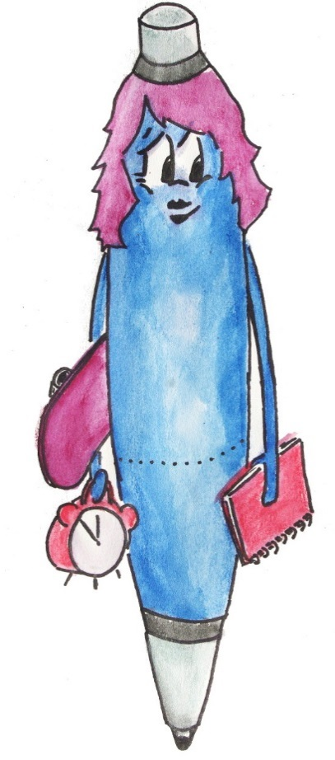
When it comes to referencing you work thoroughly and correctly. You know that in academic writing knowledge and results from other sources are used and this provides the basis for the work. That’s how new findings develop.
For you, referencing is part of your written performance. When using sources you are not yet familiar with certain working techniques or the actual reason for referencing might be not clear to you. You try to reach your goal with minimal effort. But depending on the situation you might end up making mistakes or compromises and this could create problems for you.
Your first priority is probably the content of your work and your working method is viewed as being of secondary importance to this. Academic working methods can however help you to work efficiently as well as prevent mistakes.

The strengths of your working method are:
- When writing up your work you have the individual working stages in sight. This helps you to stay on top of things and stick to deadlines. You generally know that content from other sources must be attributed to its source and you also do this.
- You note down content from other sources systematically or highlight it directly in the source. This ensures that you can be absolutely sure of the origin of the content and spares you an agonising search later on.
- You know that some mistakes are unavoidable even in a good piece of work, which relieves you of some stress when writing up your work.

The risks of your working method are:
- You try to save on time and effort. But this can lead to you underestimating the time you need for individual working stages, for example, you might not give yourself due time for thorough research or the good written presentation of your ideas. Your notes may also end up being incomplete or ambiguous in places.
- Your focus on the content of the work can encourage referencing mistakes, because you pay (too) little attention to working methods and conventions. They are usually just small things, but you could end up accidentally plagiarising.
- When you can no longer track the source of content and therefore leave it out of your work, the quality of your work’s content suffers. The same goes for incomplete references, which impair understanding.

Use your knowledge and skills consistently!

Tips & tricks

- Check how you process, evaluate and finally incorporate content from sources in your work. Always keep referencing information on your sources available together with the content. If you improve your working method, you’ll be able to further reduce the likelihood of making mistakes.
- Improve your time management, so that your time is not so much controlled by external circumstances, but much more by you yourself. For example, allow buffer time for corrections, feedback or checking references.
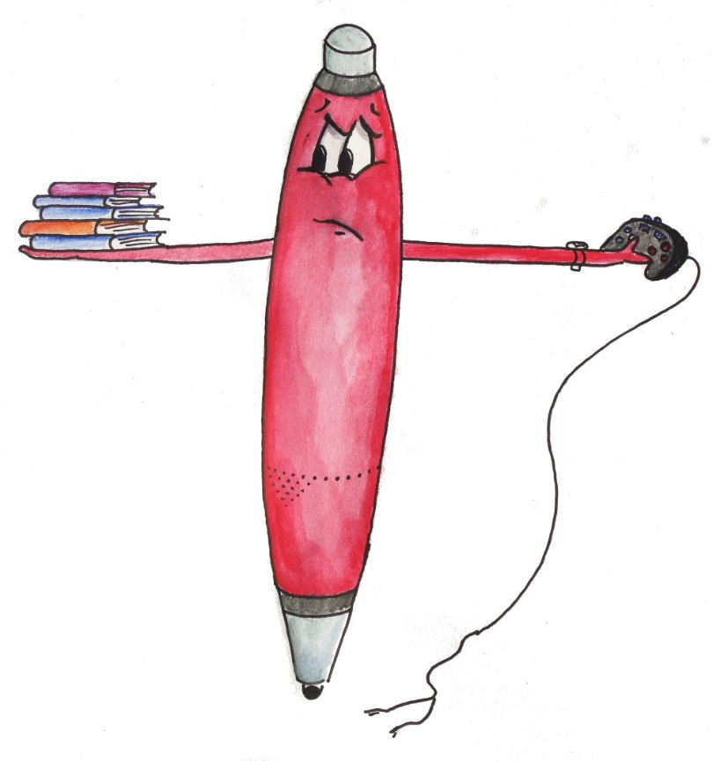
- Use reliable sources for finding information, even for working methods and referencing conventions. Examples of reliable sources are handbooks, online offers from the university and lecturers.
- Use appropriate offers of guidance and teaching at your university and in your degree course. These could include writing and IT skills, using the library, time management, managing your references, academic writing, etc.

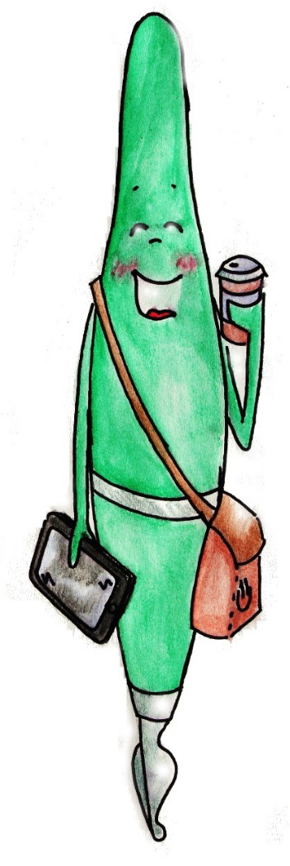
Type C: Thorough
“I can do it! Bring on the final paper.”

You work professionally. You know that in academic writing knowledge and results from other sources are used and this provides the basis for the work. That’s how new findings develop. In doing so you must of course acknowledge which sources and people the content you use comes from. This is completely clear to you.
It also goes without saying for you that good academic writing is a key requirement for learning new things and being successful in your studies. Having the right content and the correct working method are equally important to you. When using content from other works in your own work you are fair and attribute it to the author and the source.
As you are confident in referencing practices in your writing, your mind is free to creatively develop the ideas in your work. You are a master of your trade.

The strengths of your working method are:
- You have a clear overview of what content comes from other sources or other people and what your own contributions are. You can also show this by correctly referencing in your texts. You know how to incorporate content from other authors in your work both eloquently and formally. It is unlikely that you will accidentally plagiarise.
- You probably know that there are different referencing styles. Before writing up your work you make yourself familiar with the required style and its standards.
- In your work you only use content from other sources when you can also acknowledge them.
- You keep track of your material by structuring and recording your working process. Referencing therefore comes easily to you because you can rely on your notes when writing up your texts.
- You make extensive and systematic notes when researching your topic. You clearly indicate verbatim quotes and also provide references for your notes. You might also use software to manage your references or keep a log to record your academic working stages.
- Your working method lays the groundwork for very effective learning as well as clear presentation of your academic work, because you competently process content from different sources.

- You have practised and mastered working techniques. You can therefore develop content from other sources in your work without worrying and reach your goal faster and more easily.
- You allow enough time for your working process – from the research stage to feedback. In so doing you avoid time pressure, rushing and making mistakes.
- You use feedback from others as it furthers your academic success and improves the quality of your work.

The risks of your working method are:
None.

Keep up the good work!

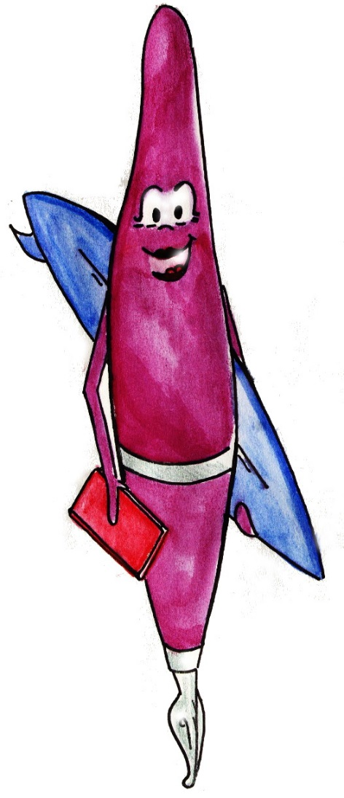
Tips & tricks
• You are on the right path. Your working techniques indicate that you work in a professional, systematic, fair and honest manner.
• Use appropriate offers of guidance and teaching at your university and in your degree course. You can master additional advanced skills in areas such as writing, IT, using the library, time management, managing your references, academic writing, etc.

Type D: Careful
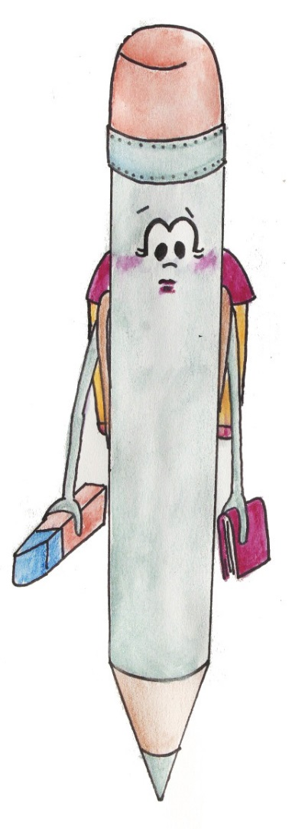
“Under no circumstances do I want to do anything wrong!”

When it comes to referencing you work thoroughly and correctly. You know that in academic writing knowledge and results from other sources are used and provide the basis for the work.
You have understood that academic writing is an important part of your work at university and that you must attribute content to its source and author.
You take referencing very seriously and are meticulous about ensuring you clearly acknowledge sources in your written work. However, referencing also worries you a lot since you are often not sure what exactly needs to be acknowledged and how you should do so. You therefore go to great lengths to hand in work that is as perfect and free of mistakes as possible. Consequently, you sometimes do not have enough time left to critically discuss the content from other sources you have used in your work.

The strengths of your working method are:
- You only use content which can also be acknowledged in your work. It is highly unlikely that you will accidentally plagiarise.
- You structure and document your working process. This helps you reference and avoid mistakes as you have such a clear overview that you can always look back at your notes when writing up your work.
- You allow enough time for the whole working process – from the research stage to feedback.
- You make extensive and systematic notes when researching your topic. You clearly indicate verbatim quotes and also provide references for your notes. You might also use software to manage your references or keep a log to record your academic working stages.
- You probably thoroughly inform yourself about referencing styles and standards before writing up your work.

The risks of your working method are:
- You end up having to work under time pressure when you spend too much time on formal questions, checking quotes and references and double-checking. In so doing you sometimes forget the actual importance of referencing. It is less a matter of dotting every “i” and crossing every “t” of the respective referencing style and much more one of ensuring that content taken from other sources is clearly attributed to them.
- You want to be absolutely sure you are working correctly and therefore check your work or ask your lecturer(s) questions more often than necessary. You can lose valuable time this way.
- You tend to give more citations than are actually necessary to clearly acknowledge content from other sources. Depending on the referencing style this can result in your work becoming less reader-friendly.
- You might leave out content from other authors when you are you not exactly sure how or whether you can reference it. The quality of your work suffers as a consequence.

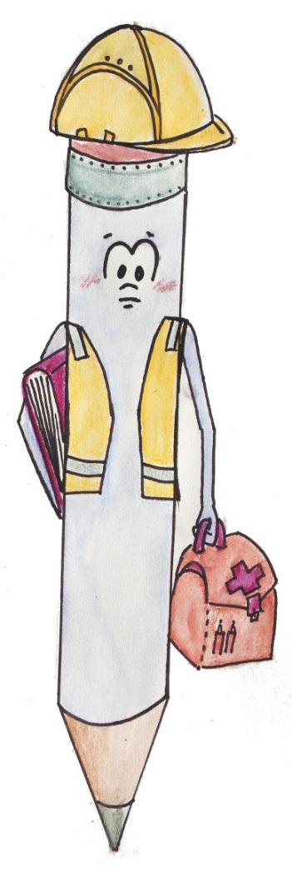
Trust your capability and develop your skills!

Tips & tricks

- If you feel unsure about referencing, find out what the exact cause of this uncertainty is. Is it integrating content from other sources eloquently and making it fit nicely in your work? Is it the question of what content actually needs to be acknowledged or are considered general knowledge? What a “good” source is and how you can find them? Do you have questions about referencing styles? Depending on the issue, use appropriate offers of guidance and teaching at your university and in your degree course. These could include writing and IT skills, using the library, time management, managing your references, academic writing, etc.
- Have a go at using software to record your references and all the information you gather on your research topic. This will help you avoid referencing mistakes, so you don’t have to invest too much time in checking them.

- Consider all the questions you have and reflect on what you specifically want to know as well as where exactly you have problems. Go to your lecturer(s) or another person with all these questions in one go instead of with each individual detailed question. This will not only save you time, but is the first step in getting an overview of where you actually need help. Maybe you’ll also manage to find a solution yourself which others can understand?
- Improve your time management. For example, allow enough time for checking and getting feedback. Then you can calmly check through your references once again. Also think about setting limits. You might find that you can check through your work less than you usually do and for this to be enough.
- To improve your confidence, when you ask others for feedback (i.e. fellow students), do not just request feedback on spelling, etc., but explicitly ask for feedback on your referencing style (e. g. Is everything consistent?), as well as attribution of content (Is content from other sources always clearly acknowledged in the work?).
- Use opportunities to practise and receive feedback. With time it will then become easier for you to judge how good your work is and you will find yourself becoming considerably more competent. You will then be able to approach your future work more calmly.

Notes to educators

This self-test with feedback for skill development is meant to activate the reflection of working habits and discussion in class. It provides an easy, playful and individual access to a complex subject.
The questions and answers neither cover all possible attitudes or individual working habits nor are the constructed types scientifically proven. They are chosen und developed based on the editors’ experience and for illustrative reasons only.
It may be introduced as homework to prepare for class or can be done directly in class. It can be helpful as a starting point for discussions about questions like
- Why do we cite? What are the underlying principles and values?
- What is expected of me and why?
- How can I avoid citation mistakes and plagiarism?
- What is my way of doing writing tasks? Which techniques could I improve?
- Which techniques are applied by others? What tips can we provide to each other?
- Where in my university can I get help to improve and learn more about it?

